**Batch: A-3 Roll No.: 16010122104**

**Experiment / assignment / tutorial No. 10**

**Grade: AA / AB / BB / BC / CC / CD /DD**

**Signature of the Staff In-charge with date**

**Experiment No.:10**

|  |
| --- |
| **TITLE: Study of Packet Analyzer tool: Wireshark** |

**AIM:** To study and analyse various Protocols using Packet Analyzer tool: Wireshark

**_____________________________________________________________________________**

**Expected Outcome of Experiment:**

**CO:**

**_____________________________________________________________________________**

**Books/ Journals/ Websites referred:**

1. A. S. Tanenbaum, “Computer Networks”, Pearson Education, Fourth Edition
2. B. A. Forouzan, “Data Communications and Networking”, TMH, Fourth Edition

_____________________________________________________________________________

**Pre Lab/ Prior Concepts:**

IPv4 Addressing, Subnetting, Link State Protocol, Router configuration Commands

**_____________________________________________________________________________**

**New Concepts to be learned: Packet Analyzer tool: Wireshark**.

**THEORY:**

Wireshark is an open-source packet analyzer, which is used for education, analysis, software development, communication protocol development, and network troubleshooting. It is used to track the packets so that each one is filtered to meet our specific needs. It is commonly called as a sniffer, network protocol analyzer, and network analyzer. It is also used by network security engineers to examine security problems. Wireshark is a free to use application which is used to apprehend the data back and forth. It is often called as a free packet sniffer computer application. It puts the network card into an unselective mode, i.e., to accept all the packets which it receives.

Uses of Wireshark:

1. It is used by network security engineers to examine security problems.

2. It allows the users to watch all the traffic being passed over the network.

3. It is used by network engineers to troubleshoot network issues.

4. It also helps to troubleshoot latency issues and malicious activities on your network.

5. It can also analyze dropped packets.

6. It helps us to know how all the devices like laptop, mobile phones, desktop, switch, routers, etc., communicate in a local network or the rest of the world.

**IMPLEMENTATION:**

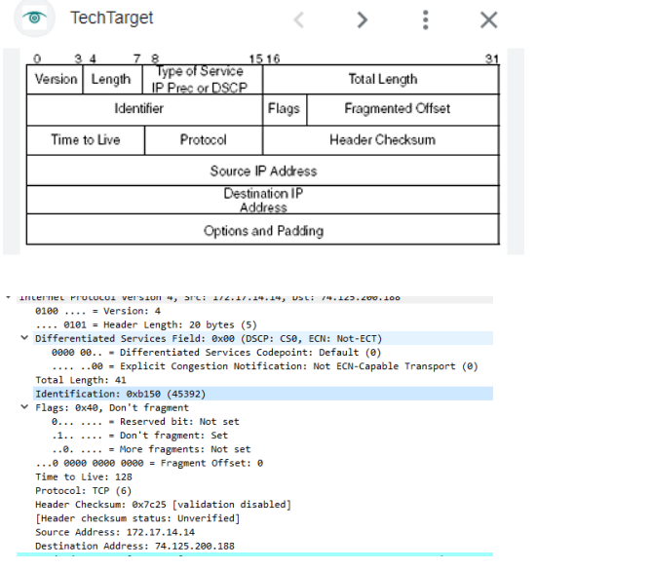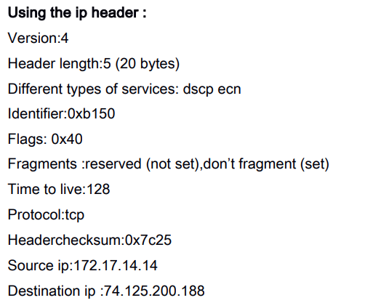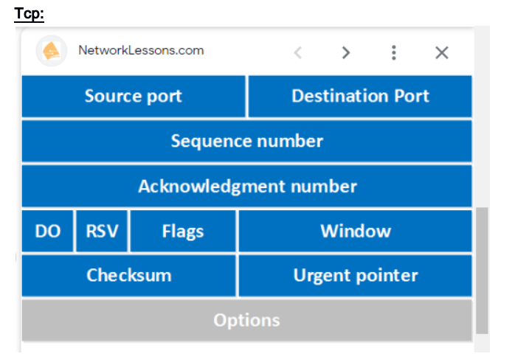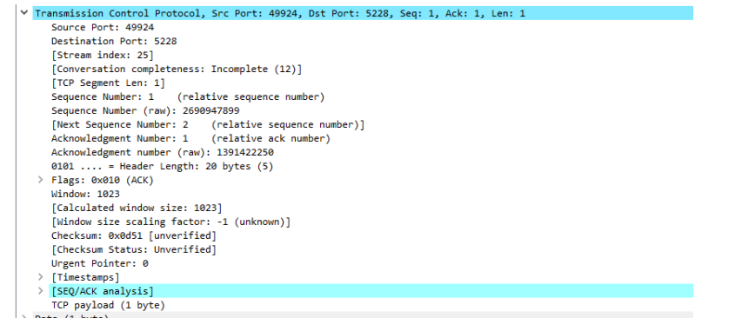

Source port:49924 Destination:5228

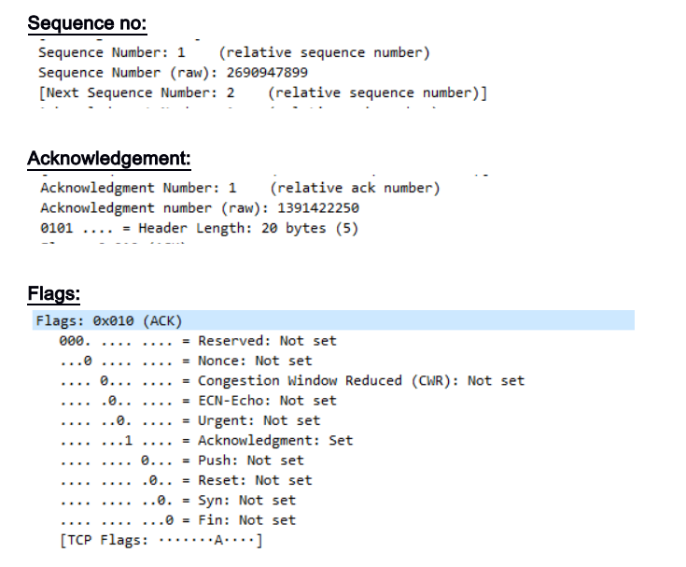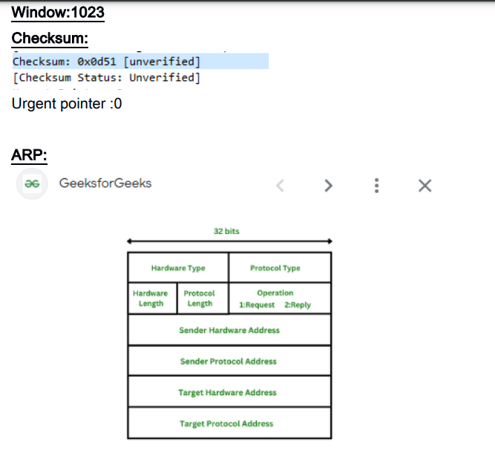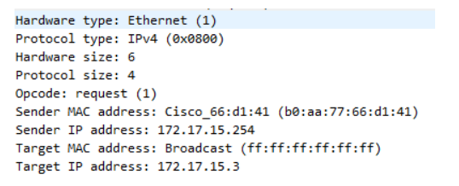

Arp takes place in frames as the data travels where only the sender and receivers Where the sender and receivers address is noted.

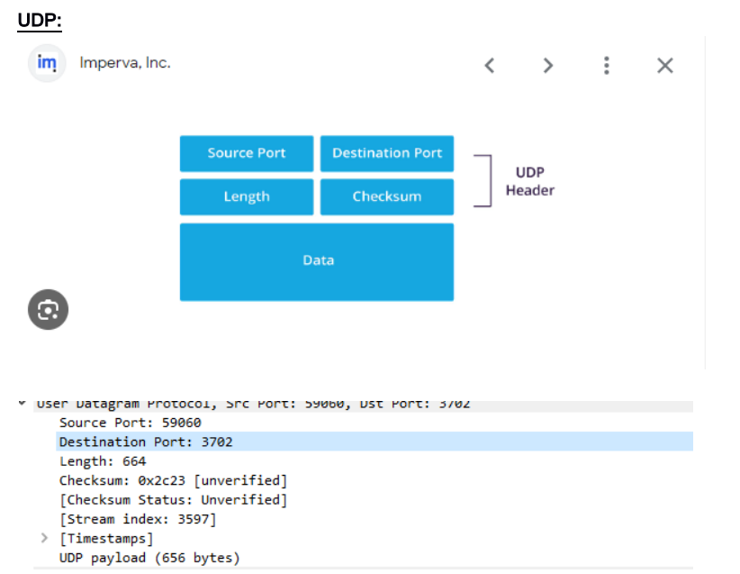

**CONCLUSION:** Thus we have implemented the wireshark experiment

**Date: 11/11/2024 Signature of faculty in-charge**